How to input %R values to use in Match Textiles

- Enter into the matching screen and on the standard box to the right on the square with the 3 dots, right click and choose ‘Input form…’

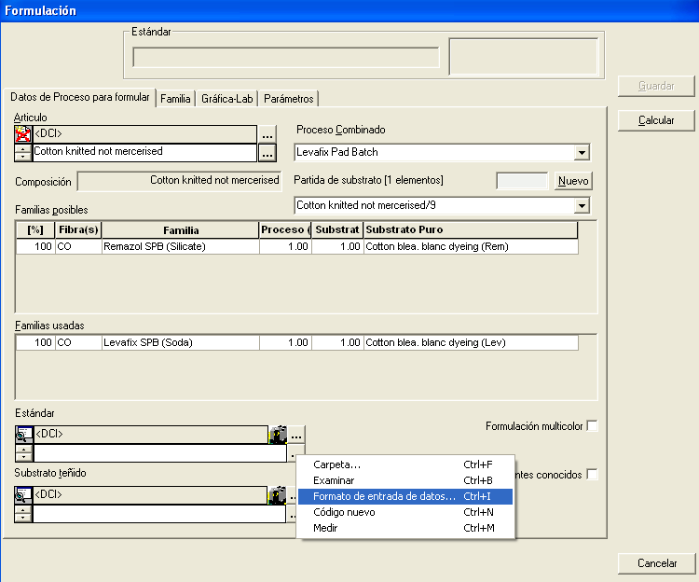

- On the sample input form below type the name of your sample ‘i.e. %R Spectral’ then click on the tab that says ‘Spectral’

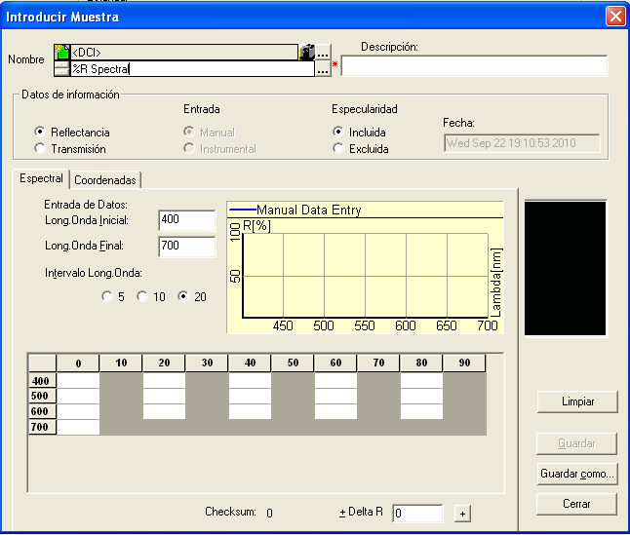

- On this tab insert the Initial and Last Wavelenght, then click in the radio button that says ‘ 5’ or ‘10’ or ‘20’ , then put in your %R values . Then click on the button ‘Insert’. Then click on the button ‘close”

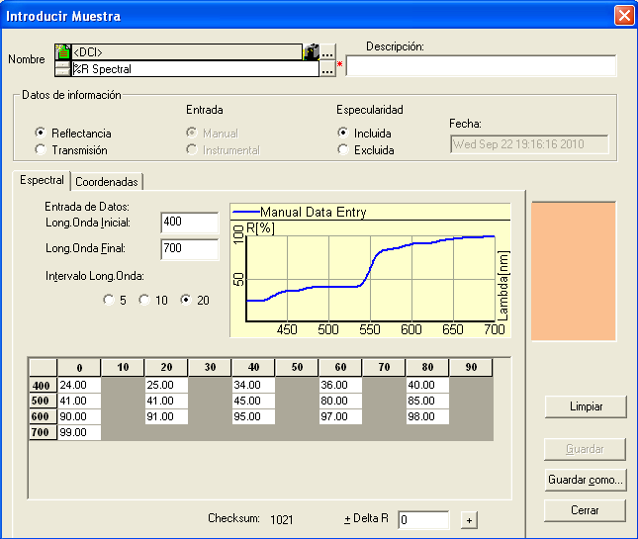

4. You will then have your sample ‘i.e. %R spectral’ available as a color to do a match under 1 illuminant.

