LAB CORRECTION (F6)

1. From the recipe explorer view click on the recipe you would like to correct.
2. Then select the lab correction icon on the recipe menu bar 

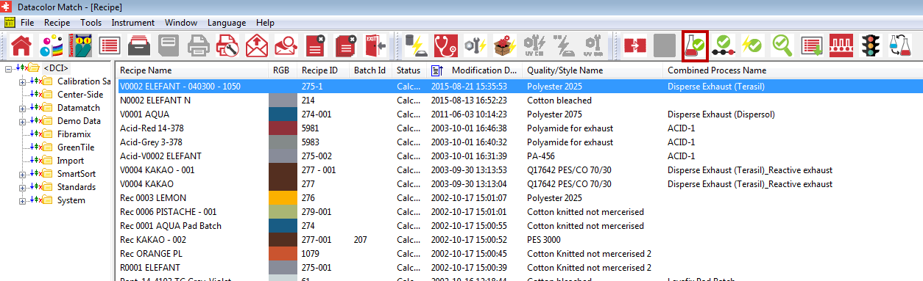

1. The next screen lets you continue with ‘pass/fail and correction’ or ‘approve’.

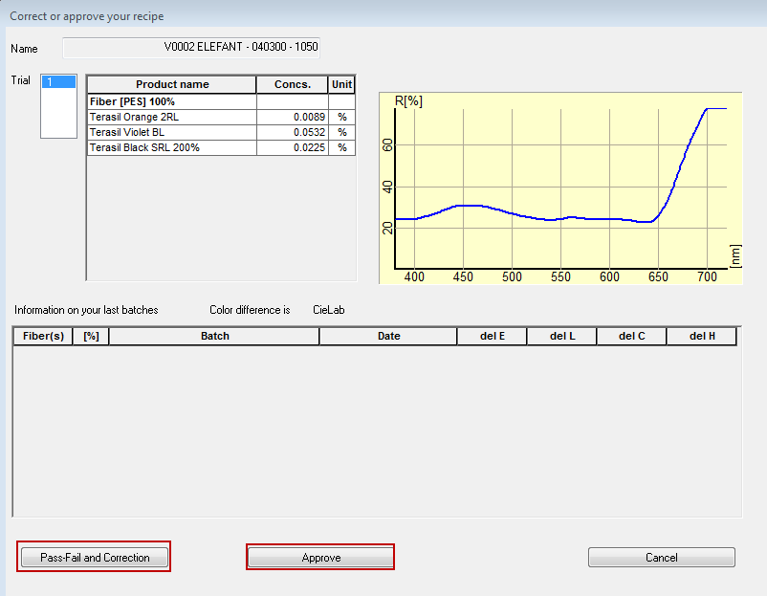

1. If you ‘approve’ the recipe is stored with the formula as is shown
2. If you click ‘Pass-Fail and Correction’ the following screen appears. This is to correct this lab dip

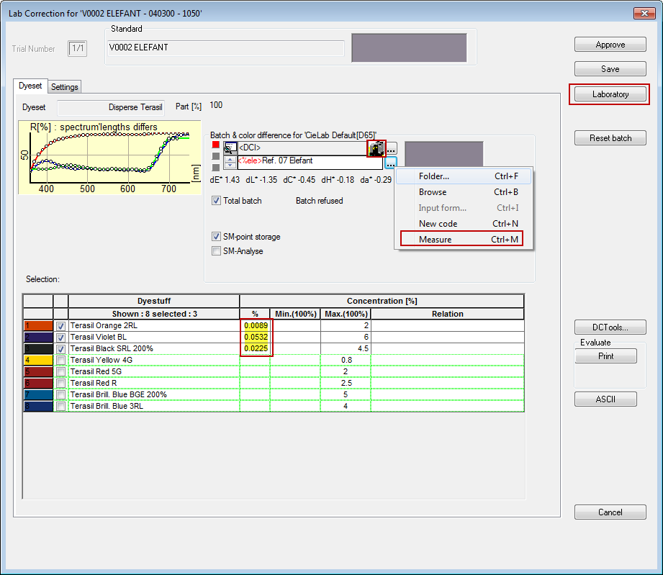

1. You then click on the spectro icon  to read in your batch one time. To take an average measurement right click on the spectro icon or the button with the 3 dots  and choose ‘Measure’(The name of the batch will be the standard name with a ‘/’ and a number, where the number represents the number of the corrections (i.e. 1234 Blue/4).
2. Double check to make sure the formula listed is that of your batch. If it is not you can manually change the formula
3. Then you click on a ‘Laboratory’ to start the lab correction

Lab correction results

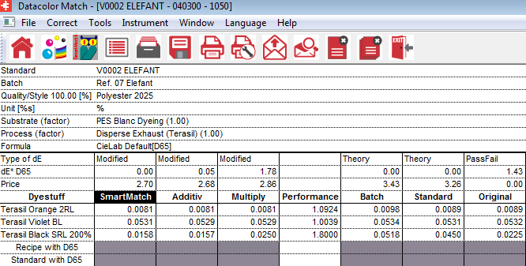

1. Five screens are displayed:

Original: The formula actually used to dye the batch.

# Standard: The formula for the dyed batch based on the primaries

Performance: Performance rating for each dye

Multiply: The new formula equal to the ‘performance’ times the ‘standard’ amount for each dye.

Additive: New formula equal to the ‘recipe’ amount plus the ‘standard’ amount minus the ‘batch’ amount.

Smartmatch: New formula calculated by using SmartMatch points

Always use the ‘Smartmatch’ formula if it is available. If there is no ‘Smartmatch’ formula and the ‘Performance’ amounts are between .5 and 1.5, use the ‘Multiply. If the ‘Performances’ are outside of the desired range (.5-1.5), use the ‘Additive’ formula

1. Click on save icon  to save the highlighted recipe. This will update the recipe with the new formula so that when the next correction is done it will have the most up to date recipe.