**Matching a Color (F5)**

1. From the overview page select the recipe button

1. Then select the match icon on the recipe menu bar. (You may also click on ‘recipe’ and choose ‘match’ from the drop down menu.)



1. The next screen is the matching screen.

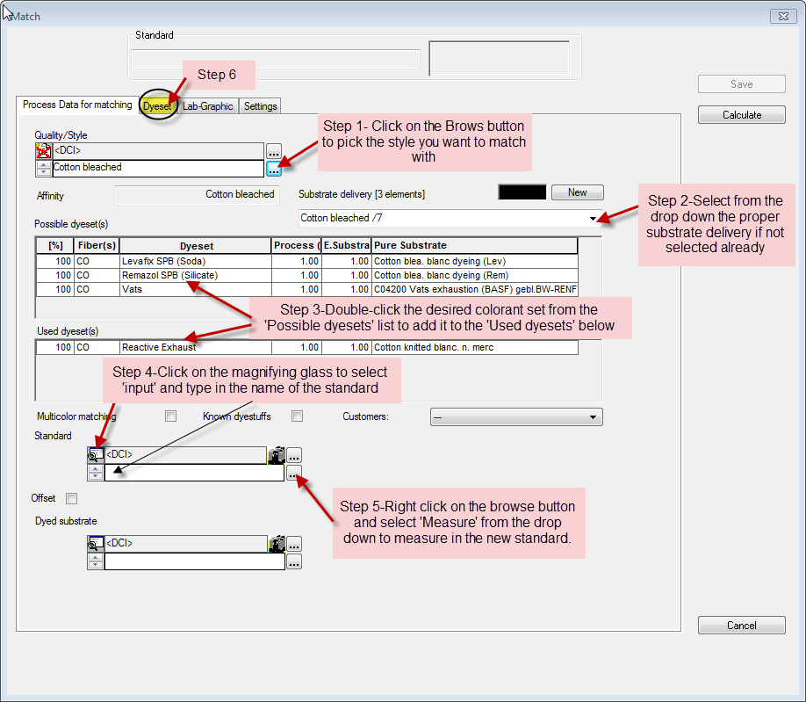

1. Step 1 is to browse for your quality/style.



1. Step 2 is to select your ‘substrate delivery’ which represents any differences in the substrate color. The desired ‘substrate delivery’ may already be present by default.
2. Step 3 is to select your dyeset by double-clicking it from the list of ‘Possible dyesets’. This will place the dyeset in the ‘used dyeset(s)’ section of the screen.
3. Step 4 is to change the select button  to input  so you can type in the name of your standard. Type in the name of the standard.
4. Step 5 is to right click on the browse button  and choose ‘measure’ from the drop down menu. ( If you only wish to measure your standard once you may click on the spectro icon  )
5. Step 6 is select individual dyes used in the dyeset you have chosen you must click on the page tab that says ‘dyeset’.

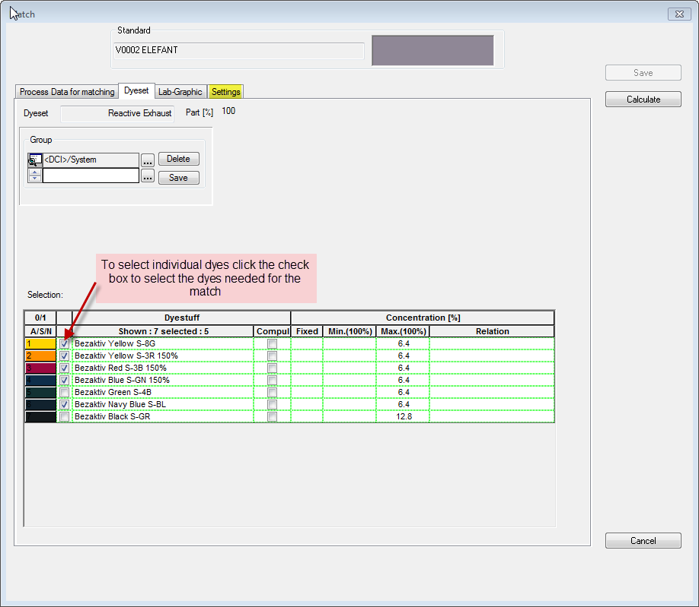

1. On the dyeset tab select the individual dyes by clicking on the check boxes to select them.
2. Click on the ‘Settings’ tab to select the particular requirements for the Match. Important setting are listed below
   1. Number of dyes in a recipe
   2. Number of illuminants to match under
   3. Matching Technology i.e. smartmatch or normal match
   4. ‘Save as User Default’ Once all settings are determined this button should be clicked. IT IS VERY IMPORTANT TO SAVE THESE SETTINGS BEFORE AN INITIAL MATCH IS MADE.

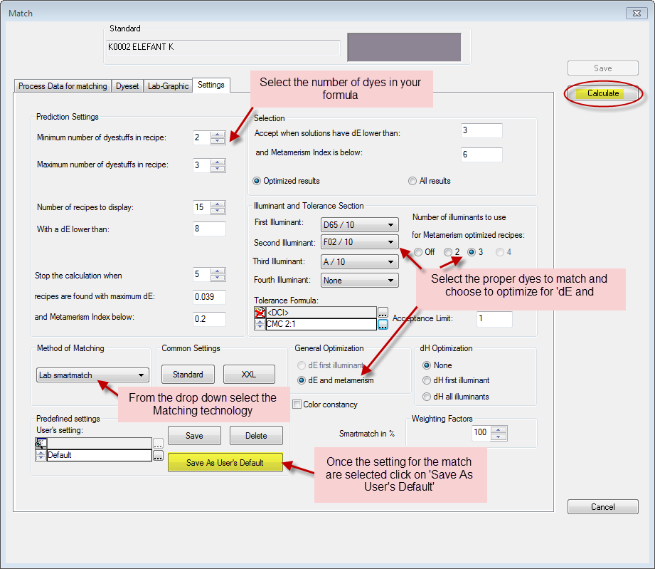

1. click the Calculate button .
2. This will then take you to the lab recipe display.

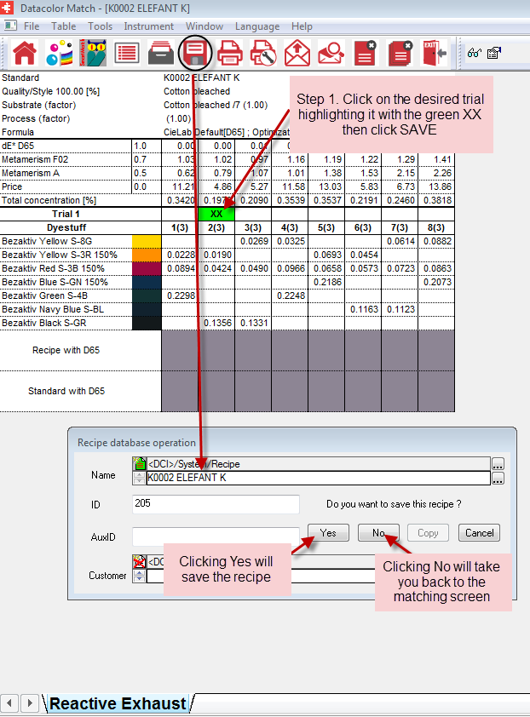

a. Step 1 On this page you will select your recipe by clicking in the trial row above the recipe you wish to use. (If you wish to select more recipes to try right-click and choose ‘add trial’ to add more.)

b. Step 2 You will then click the save button  and display the ‘recipe database operation’ screen. Click ‘yes’ to store the recipe.

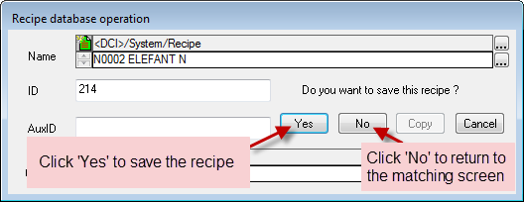

7. You will then have the option to ‘show’, ‘print’, ‘dispense’, ‘ASCII output’ or ‘Email’ the recipe. Click on the desired button.

