CREATING A NEW DYEPROCESS

1. From the main screen Click on the button that says ‘Dyeprocess’

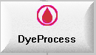

1. You will come into an ‘explorer’ type screen(see below). Double Click on the right hand side of explorer view or right click and choose ‘dyeprocess’.

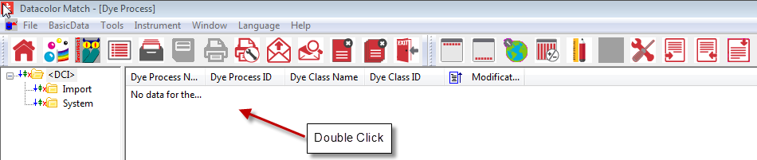

1. The dye process dialog box is shown below.

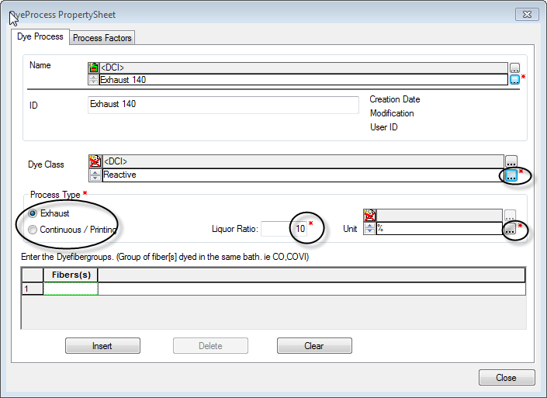

\* All inputs with an astericks(\*) are mandatory inputs!

1. Type in the name of the dyeprocess i.e. Exhaust 140 then click in the ID box.
2. Next you must browse  for the ‘dyeclass’ which this process will be used with.
3. The process type is then chosen by clicking on the radio button-contiuous or exhaust.
4. The liquor ratio must be input
5. Then the units for the recipe can be browsed  for and specified.
6. To save this dyeprocess you click on the ‘insert’ button.

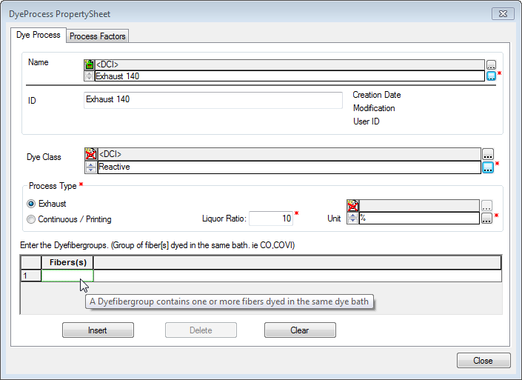

1. Select the green box to pick your fiber.

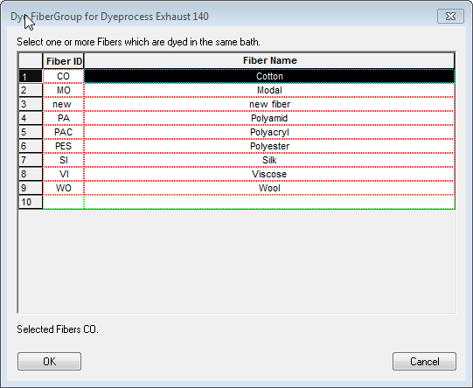

1. Select your fiber then click ‘ok’

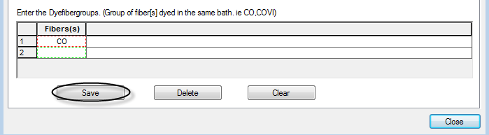

1. Then click ‘save’ to save your dyeprocess.