Import and Export from Match Textile

The types of files that can be imported or exported are:

1) Files with the .**exp**(and .exq) extension are an older format which compatible with Datamatch, Datacolor’s previous generation of color matching software. THIS WILL IMPORT SAMPLES ONLY INTO MATCH TEXTILES. IT WILL GO TO THE ‘IMPORT FOLDER’

2) **.qtx** format is the format which is used by our current Tools, Envision and older colortools programs. This is what you would use to send to someone with just a QC program

3) **.xml (samples)** format is used to export color samples from the Match database to another system with Match Textiles.

4) **.xml (Dyesets)** is to export colorant(or dye) sets in between Match Textile systems.

Importing information into Match Textile

When importing information into Match it is important to know what is being imported. File extensions of .exp and .qtx will always import color samples and these will be found in the ‘Import’ folder in Match under the button ‘Sample’.

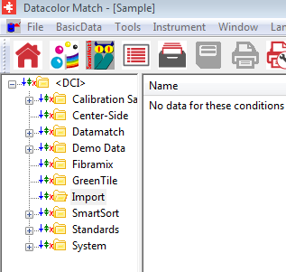

Those import files with the extension .xml will import either as samples or a complete colorant set. If they are samples they will import into the folder ‘Import’ in Match Textiles as above. If they are a colorant sets they can be seen under the button ‘colorant sets’

1. To import a file click on ‘Tools’ then ‘Import’ (below) or choose the import button  from the ribbon bar

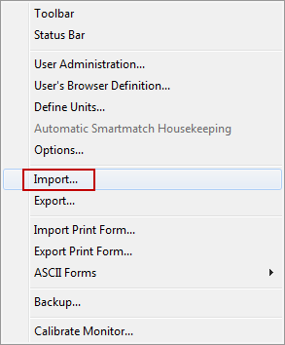

1. Click the browse button and locate your file to import.(in our example the extension is .exp. Highlight it and Click ‘ok

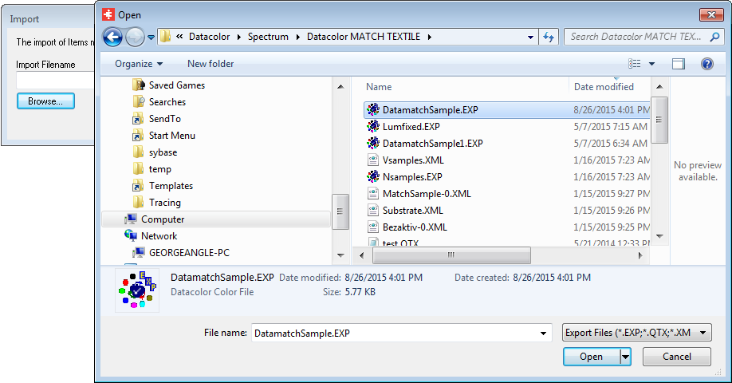

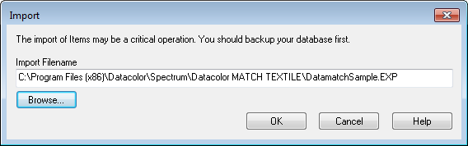

1. Click ‘ok’ again at the box above and your samples will import into the ‘import’ folder under the ‘sample’ 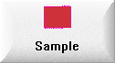 button.

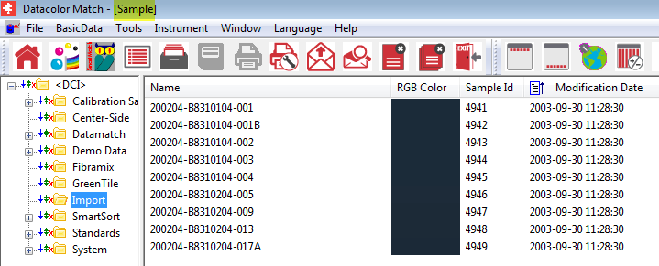

1. Note: if this was an .xml file with a dyeset you can find it under the button ‘Colorant Set’ in the folder ‘Import’. Also with a dyeset the associated samples for the dyeset will be located in the folder ‘import’ under the ‘sample’ button

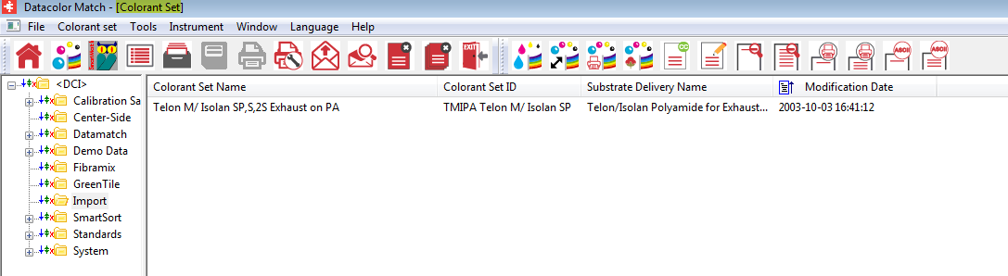

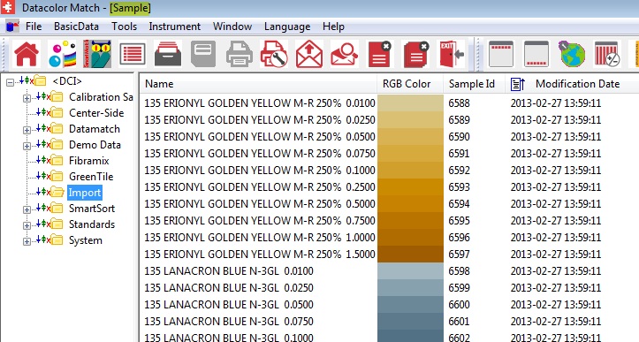

**\*\*\*\* NOTE: If you are importing a number of files you may wish to rename the import folder after importing so you do not mix the samples you have imported!!. Match Textiles will create a new import folder if the old one has been renamed. This is important for keeping track of what is imported in each file.\*\*\*\*\*\*\*\*\***

To rename the import folder right click to folder and choose’ rename’

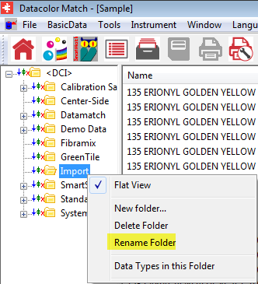

To export from Match Textile:

1. Click on ‘Tools’ from the menu bar then ‘Export’ from the drop down menu or choose the ‘export’ icon  from the ribbon bar
2. The screen will be displayed as on the next page.

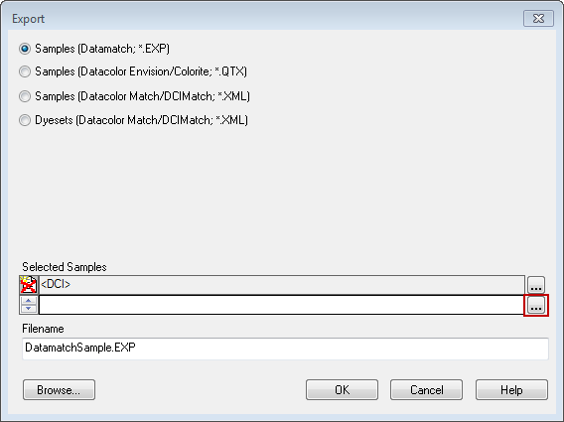

1. You will select the file type you would like to export (Shown above it is samples with a .exp extension above). **Note: if you are sending to a Tools only system .QTX extension would be your choice.**
2. You will then browse for the samples you would like to export by clicking the button with 3 dots at the bottom right.

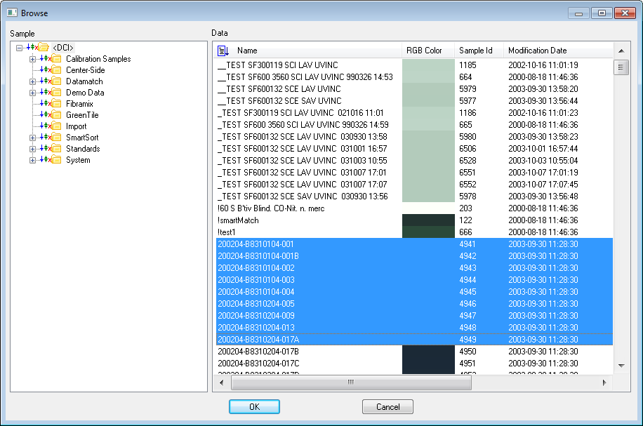

1. Highlight the samples you want to export and click ‘ok’

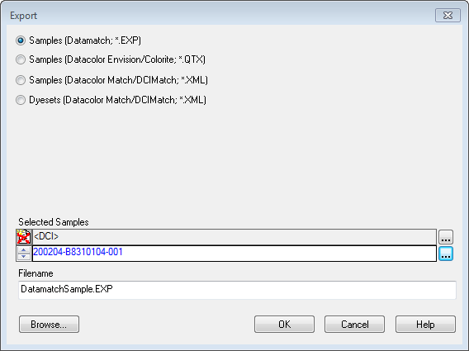

1. If there are multiple samples they will show up in blue under ‘Selected Samples’.
2. The file name to export will be ‘DatamatchSample.exp’. By default the path for export is ‘C:\program files\datacolor\Spectrum\Datacolor Match Textile’.(See Below)

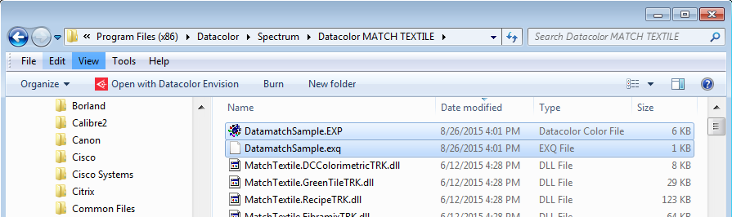

1. These files can now be copied or sent to another system and imported(using the instructions above for importing into Match Textiles